**Williams, Fred (1927-1982)**

Fred Williams was an Australian painter and printmaker who bridged the gulf between the country's landscape painters and contemporary art. In the 1960s he turned the sparseness of the Australian countryside into pictures that resembled the international trends toward abstraction and minimalism. These were large, sparse canvases dotted with colourful blobs that alluded to the great spaces and minimal features of the Australian countryside. Williams's other influential series include paintings of densely packed trees in Sherbrooke Forest in the late 1950s and early 1960s, and landscapes of the Pilbara region in the early 1980s, just before his death. The Pilbara series would come to be his best known work, yet they were also the most conservative of Williams' pictures, as they picture the ranges and riverbeds of this region with a naturalism redolent of classical landscape painting. It is as if in these works the radical break that took place in Australian art in the 1960s and 1970s had never happened, that the influence of contemporary art had not succeeded in making itself felt.

Thus Williams continues to represent one of the great paradoxes of Australian art history, as he remained committed to landscape painting while also being embraced by his more radical contemporaries for his works of the 1960s. This difference marked Williams out from other successful Australian artists. After studying under modern artist George Bell in Melbourne, Williams went to London for much of the 1950s, but it was not until he turned to the landscapes around his home of Melbourne in 1957 that his talent became most visible. At the time Australian landscape painting was maligned for its 'gum tree school' amateurism. Yet it was the landscape that was to prove so productive for Williams. Without a driving license, he depended on his wife and fellow artists to return him to favoured painting spots. He often worked on *plein air* studies before rendering them as full sized oil paintings in his home studio. The places around Melbourne make up the titles of many of his paintings, including Upwey, You Yangs, Mittagong, Queencliffe and Lysterfield, however, art critics, most influentially Ian Burn, have long argued that these landscapes could be anywhere in Australia, as Williams' pictures abstract the basic shapes of the scene. Yet other critics remind us of the importance of landscape to his practice and the roots of his pictures in *plein air* painting. Since his death in 1982, the circulation of Patrick McCaughey's major monograph on the artist and the close management of his estate by his widow, Lyn Williams, have ensured the growth of his reputation and the value of his work.

**Further Reading**

Burn, I. (1991) 'Fred Williams: 'That's how a landscape should be, even if it isn't', *Dialogue: Writings in Art History*, Sydney: Allen and Unwin, 1991: 86-93. (The most influential piece of art criticism on Williams).

Hart, D. (2011) *Fred Williams: Infinite Horizons*, Canberra: National Gallery of Australia.(An exhibition catalogue that draws on the artist's unpublished diaries).

McCaughey, P. (1980) *Fred Williams*, Sydney: Bay Books. (The major monograph on the artist).

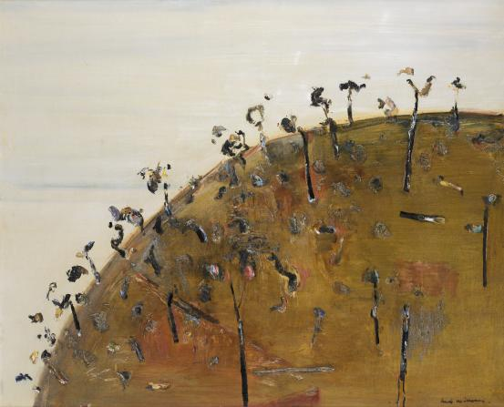

Fred Williams, *Dark Hillside*, 1967 dated 1964, oil and tempera on canvas, 108 x 132.8 cm, National Gallery of Victoria, Melbourne  
The Joseph Brown Collection. Presented through the NGV Foundation by Dr Joseph Brown AO OBE, Honorary Life Benefactor, 2004  
© Estate of Fred Williams